CL_BSP_WD_MESSAGE_SERVICE
ZDPP_ENROLLMENT
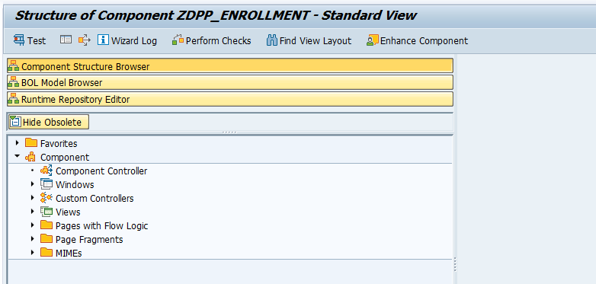

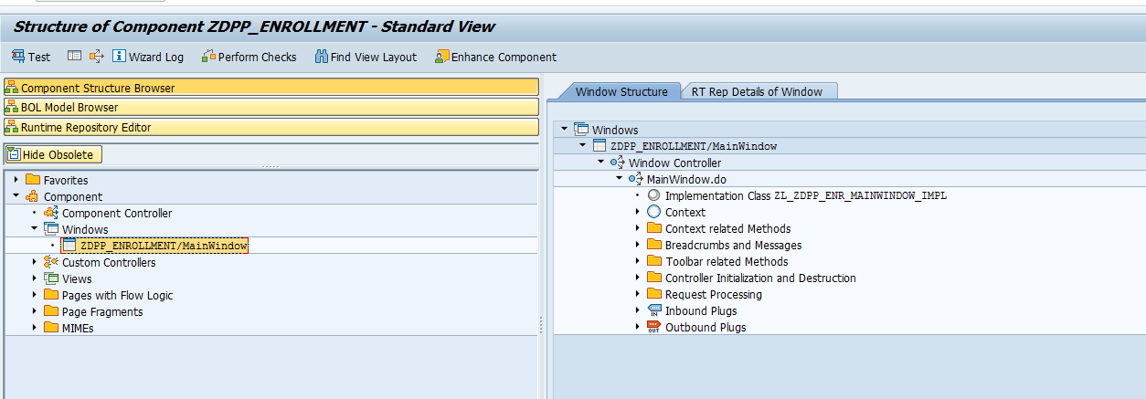

ZL_ZDPP_ENR_BSPWDCOMPONEN
ZL_ZDPP_ENR_BSPWDCOMPONEN_CN00
ZL_ZDPP_ENR_BSPWDCOMPONEN_CN01
ZL_ZDPP_ENR_BSPWDCOMPONEN_CN02
ZL_ZDPP_ENR_BSPWDCOMPONEN_CN03
ZL_ZDPP_ENR_BSPWDCOMPONEN_CN04
ZL_ZDPP_ENR_BSPWDCOMPONEN_CN05
ZL_ZDPP_ENR_BSPWDCOMPONEN_CN06
ZL_ZDPP_ENR_BSPWDCOMPONEN_CN07
ZL_ZDPP_ENR_BSPWDCOMPONEN_CN08
ZL_ZDPP_ENR_BSPWDCOMPONEN_CN09
ZL_ZDPP_ENR_BSPWDCOMPONEN_CTXT
ZL_ZDPP_ENR_BSPWDCOMPONEN_IMPL
ZL_ZDPP_ENR_DEENROLL
ZL_ZDPP_ENR_DEENROLL_CTXT
ZL_ZDPP_ENR_DEENROLL_IMPL
ZL_ZDPP_ENR_DPPPREFERENCE
ZL_ZDPP_ENR_DPPPREFERENCE_CTXT
ZL_ZDPP_ENR_DPPPREFERENCE_IMPL
ZL_ZDPP_ENR_ENROLL
ZL_ZDPP_ENR_ENROLL_CN00
ZL_ZDPP_ENR_ENROLL_CTXT
ZL_ZDPP_ENR_ENROLL_IMPL
ZL_ZDPP_ENR_ENROLLMENTVS
ZL_ZDPP_ENR_ENROLLMENTVS_CTXT

ZL_ZDPP_ENR_BSPWDCOMPONEN_IMPL
ZL_ZDPP_ENR_DEENROLL
ZL_ZDPP_ENR_DEENROLL_CTXT
ZL_ZDPP_ENR_DEENROLL_IMPL
ZL_ZDPP_ENR_DPPPREFERENCE
ZL_ZDPP_ENR_DPPPREFERENCE_CTXT
ZL_ZDPP_ENR_DPPPREFERENCE_IMPL
ZL_ZDPP_ENR_ENROLL
ZL_ZDPP_ENR_ENROLL_CN00
ZL_ZDPP_ENR_ENROLL_CTXT
ZL_ZDPP_ENR_ENROLL_IMPL
ZL_ZDPP_ENR_ENROLLMENTVS
ZL_ZDPP_ENR_ENROLLMENTVS_CTXT
ZL_ZDPP_ENR_ENROLLMENTVS_IMPL
ZL_ZDPP_ENR_INFO
ZL_ZDPP_ENR_INFO_CTXT
ZL_ZDPP_ENR_INFO_IMPL
ZL_ZDPP_ENR_MAINWINDOW
ZL_ZDPP_ENR_MAINWINDOW_CTXT
ZL_ZDPP_ENR_MAINWINDOW_IMPL
ZL_ZDPP_ENR_MESSAGES
ZL_ZDPP_ENR_MESSAGES_CN00
ZL_ZDPP_ENR_MESSAGES_CTXT
ZL_ZDPP_ENR_MESSAGES_IMPL
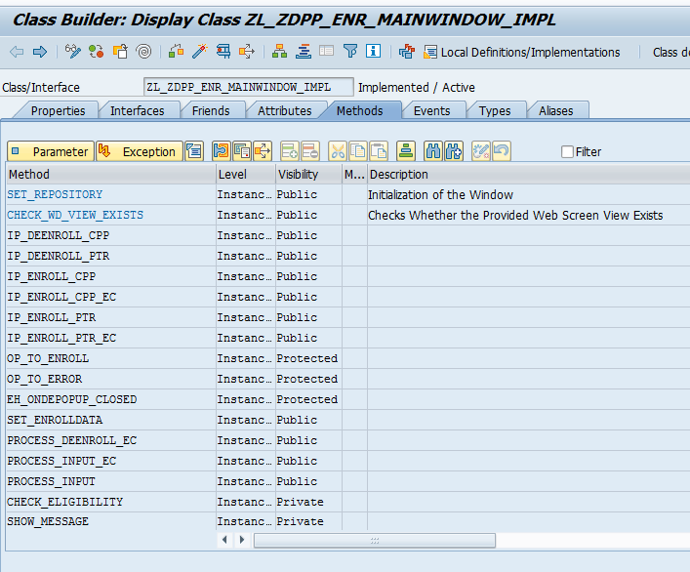

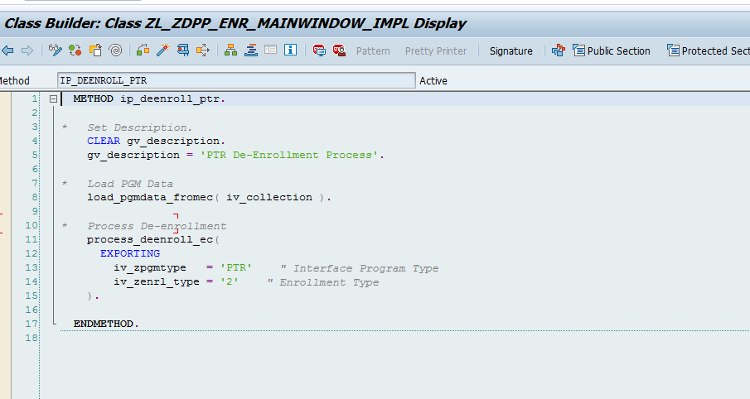

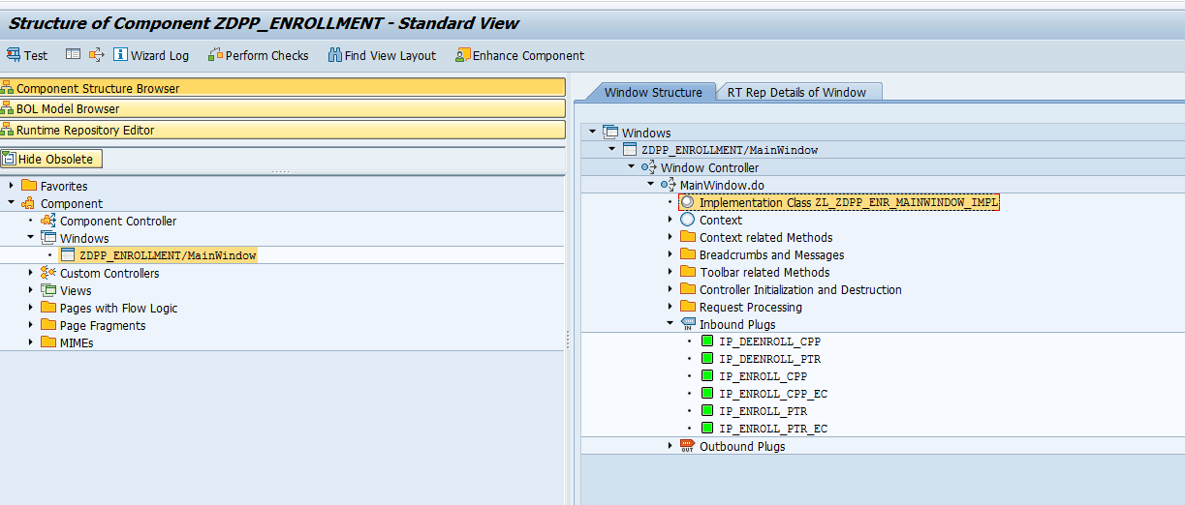

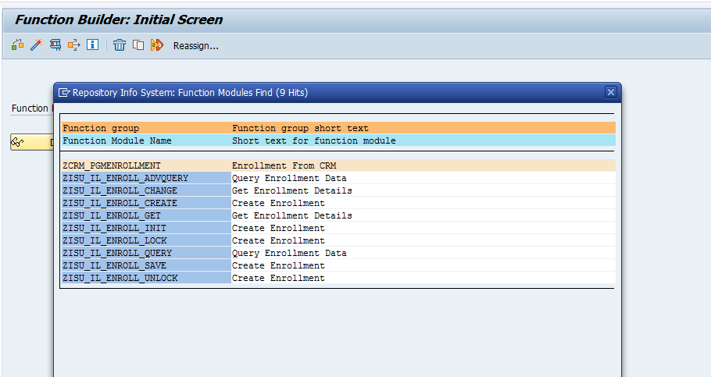

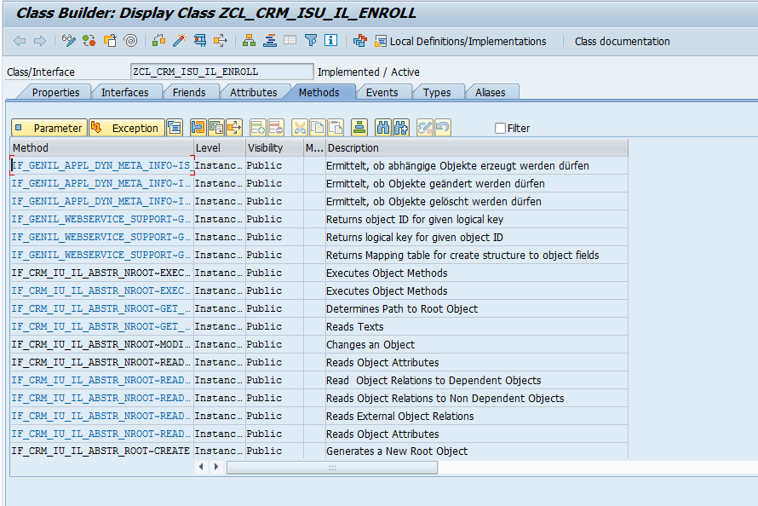
BRF Plus:-
PGMENRL_PRECHECK
PGMENRL_PRECHECK
Function:- FUNC_PGMENRL_PRECHECK
